**WORLD SNAKES DAY**

**16-07-2024**

**On behalf of world Snakes Day, Zoology department conducted Quiz competition to the students. Our Principal S.Prakash sir and other staff members attended the programme and gave valuable information to students.**

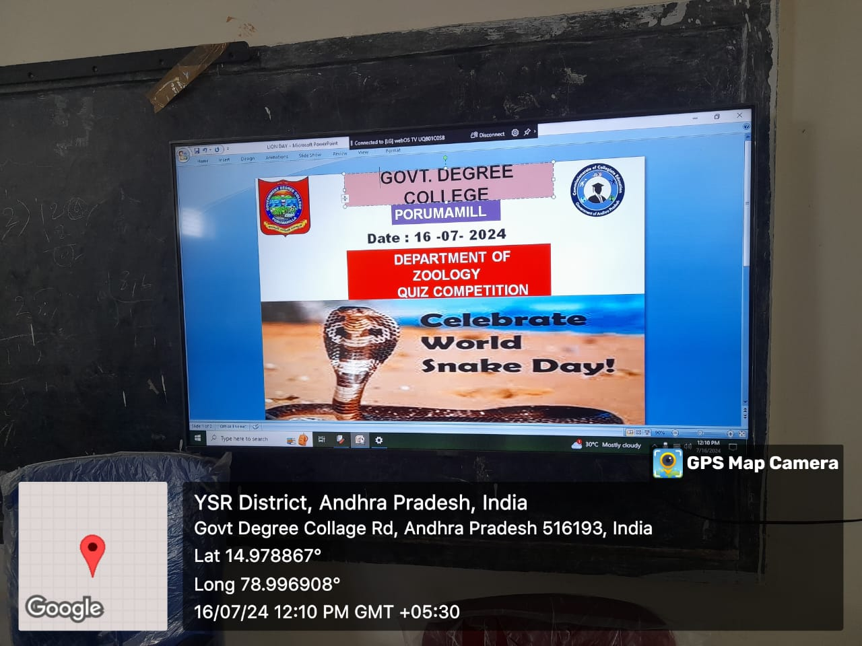

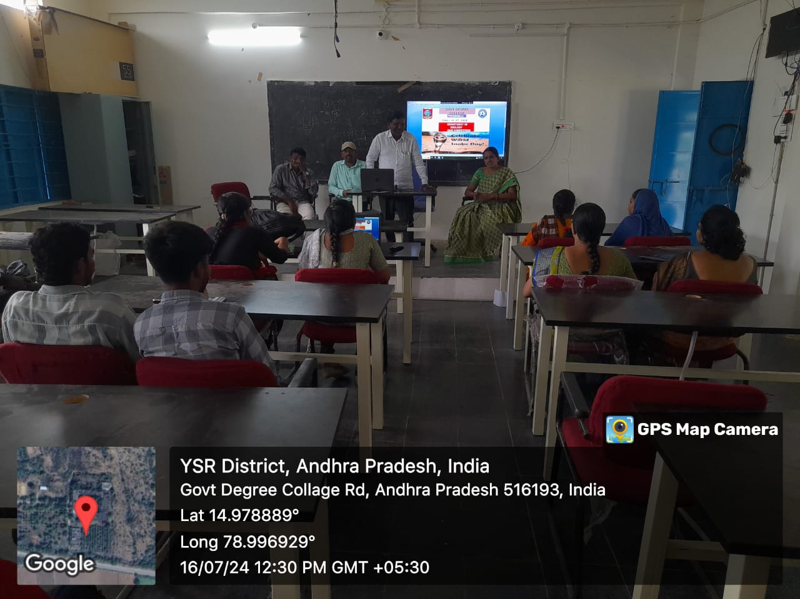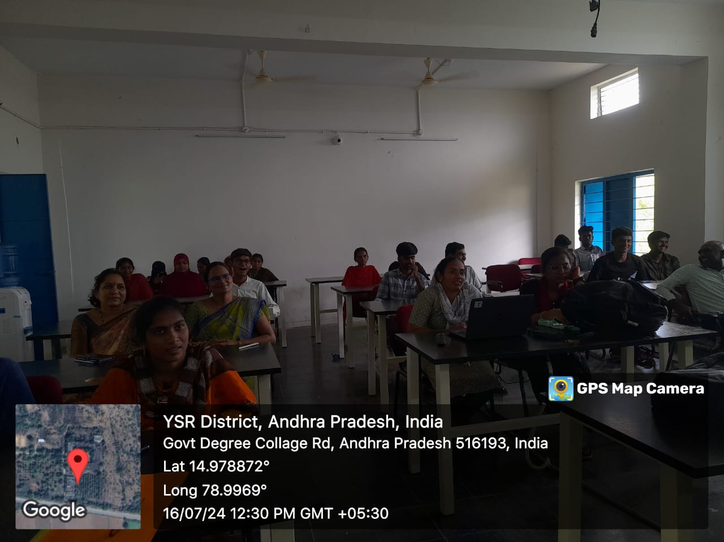

**OUT COME**

1. **Students gained knowledge about the difference between Non-poisonous and poisonous snakes.**
2. **Also acquired knowledge about First-Aid after snake bite.**
3. **Non science students also attendend the programme with interest and gained knowledge about the facts of snakes.**

**Lecturers Principal**

**Students**